# SUPPORTING INFORMATION

Additional supporting information may be found online in the Supporting Information section at the end of the article.

## Text S1 The specifics of the UCRSFN network processing data

1. The input data of the UCRSFN network is a pair of reversed phase-encoding images (UP/DOWN) of the EPI sequence, and the outputs are two field maps for UP and DOWN, respectively.
2. The input into the network first goes through a convolution, a batch normalization (BN) operation, and a max-pooling layer to accelerate the model training.
3. The output of the max-pooling layer is passed through two encoder-decoder blocks to obtain the feature maps of different resolutions.
4. Every feature map is passed through two different RLR modules to obtain two coefficient matrices with different sizes.
5. Each coefficient matrix is multiplied with a pre-generated basis set to obtain the corresponding final field map component base on the BPM module.

## Text S2 Detail of susceptibility artifacts

Here, we assume the susceptibility artifacts only exist in the PE direction, and the acquired signal for two-dimensional ssEPI in k-space can be given.

 (S2-1)

Where  and  denote gradient amplitude and duration, respectively.  is the local field inhomogeneity.  denotes a map of the density of excited protons,  denotes echo spacing.  and  denote the frequency-encoding and slice-selection direction respectively. From formula 1, we can notice that the signal from the real space location  will be shifted to distorted location, where . And the shift in units of pixels (named displacement map) can be written as , where  indicates the resolution of one pixel. ,  denotes the field of view and phase encoding number, respectively. Moreover, the intensity of the distorted image will be proportional to the spin density, so if the distortion causes local compression, the signal strength will be higher through the compression. We can infer that the undistortion image needs to be obtained after the displacement correction and intensity correction of the distorted image.

## Text S3 Pixel-wise Jacobian modulation

The distortion caused by susceptibility artifacts can be classified into geometric deformation, which is related to pixel shift, and intensity variation. Intensity variation manifests as unexpected bright or dark regions in the images, arising from pixel intensity accumulation or dispersion that comes along with pixel shift. In high-resolution imaging, with the aggravated image deformation due to lengthened echo spacing (ESP), intensity variation becomes prominent, especially in regions with highly inhomogeneous magnetic field, such as the frontal lobe and bilateral temporal lobes.

The traditional correction module will perform both geometric and intensity correction to obtain the undistorted image. From formula (S2-1), we can infer that susceptibility artifact correction can be divided into 2 steps: geometric and intensity correction. The geometric correction is performed in order to recover each pixel's real intensity  from the corresponding position , where  is the shift in units of pixels. But as the image intensity will be proportional to the spin density, if distortion leads to local compression, the signal will be higher by the accumulation due to compression, and vice versa in case of local stretching. Thus, the intensity correction is necessary. The intensity can be directly scaled by the Jacobian , which is the derivative of the offset point (displacement map), termed as JField in this paper.

 (S3-1)

Then, the corresponding geometric and intensity correction can be expressed as follows using the formula (S2-2).

 (S3-2)

But because the displacement map generally is spatially smooth, the Jacobian matrix will also be smooth, so its accuracy will be affected by the partial volume effects in areas where the B0 field changes unevenly. Here, we use a new intensity correction method that is further smoothed in vivo experiments based on the two geometric corrected images in a pixel-wise manner, termed as JRPG. The traditional way to calculate the Jacobian matrix is based on Numerical discrete differentiation as the field image is a digital image composed of discrete pixels. To overcome discrete numerical differentiation, the method that can derive the intensity of the undistorted image directly without the Jacobian calculation by combining the pair of corresponding pixels from the two EPI images with opposite PE directions is used, shown in Equation (1) in the manuscript.

## Text S4 The detailed description of the cycle consistency of the UCRSF method

The main idea of our cycle-consistency is shown in Figure 1(b) of the main body of the paper. After obtaining the undistorted image, we can use the physical model to construct the new distorted images ( and ). Based on the new distorted images, we can utilize our cycle-consistency loss to retain the characteristics of the original images except for artifacts to a greater extent.

The network is trained with cycle-consistency loss, without any explicit knowledge of the ground displacement map.

 (S4-1)

And in Figure 1(c) of the main body of the paper, we can see that the network has optimized the cycle-consistency loss between the cycle images ( and ) which are obtained by the forward model with the displacement map and uncorrected image s ( and ). The whole procedure of calculating  contains the following two steps:

1) Using Equation (1) of the main body of the paper to get the final corrected image.

2) After we obtain the corrected image, the forward model is applied to obtain the  and , according to Equation (1).

## Additional clinical data results

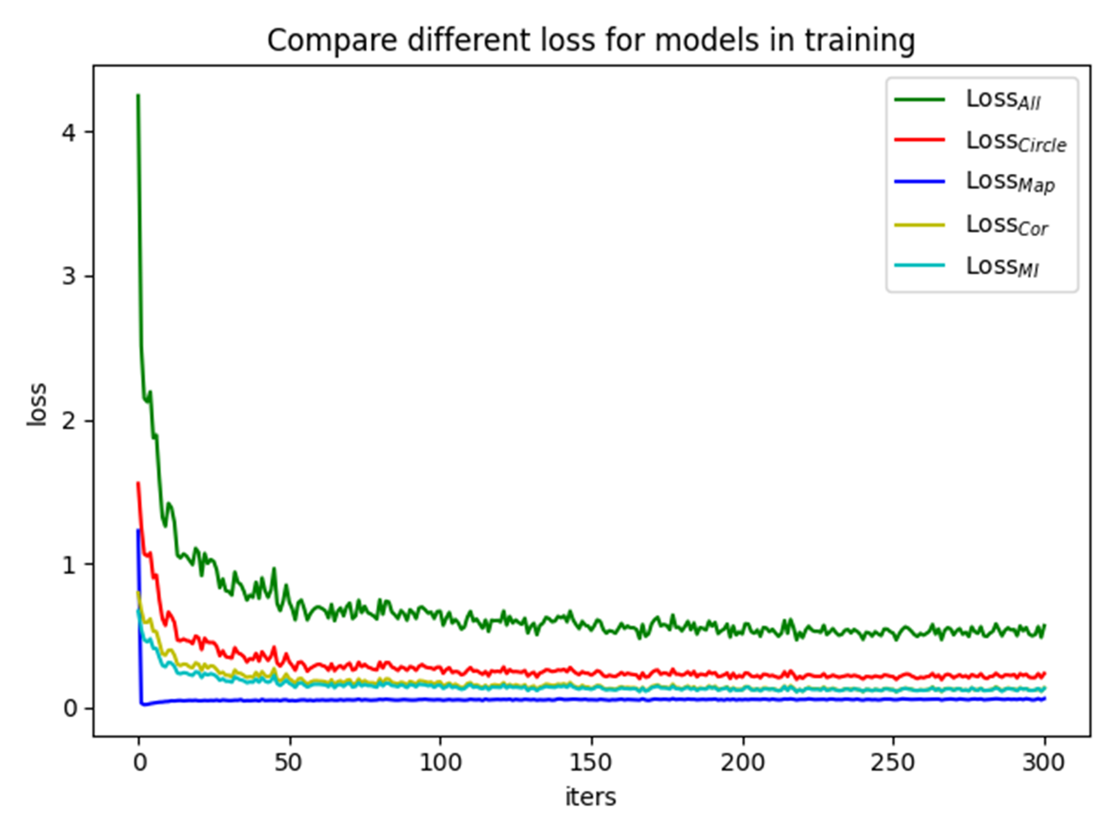

**FIGURE S1.** Learning curves of the proposed methods. The x axis represents the number of training epochs.

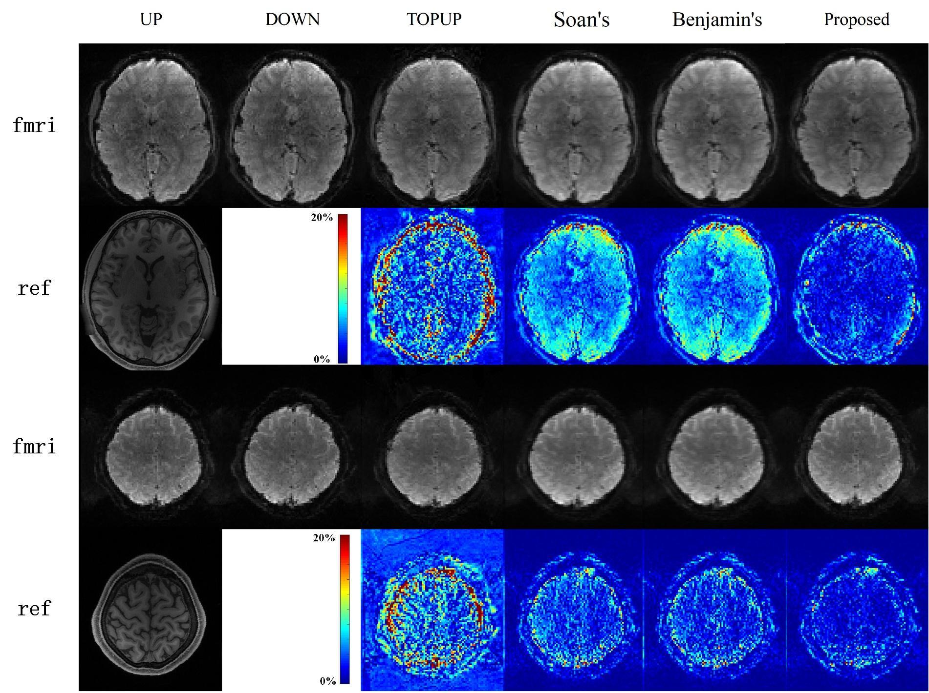

**FIGURE S2.** Comparison of the correction results for b5 images of DWI-3T test data. The edges extracted from the corresponding T2 images are overlaid onto the corrected images. The 1st and 4rd row show uncorrected images and the corresponding corrected images for different slices. The 2nd and 5th row display the T1 image and the corresponding absolute error maps between Cycle UP and UP. The 3nd and 6th row show the corresponding absolute error maps between corrected UP and corrected DOWN images.

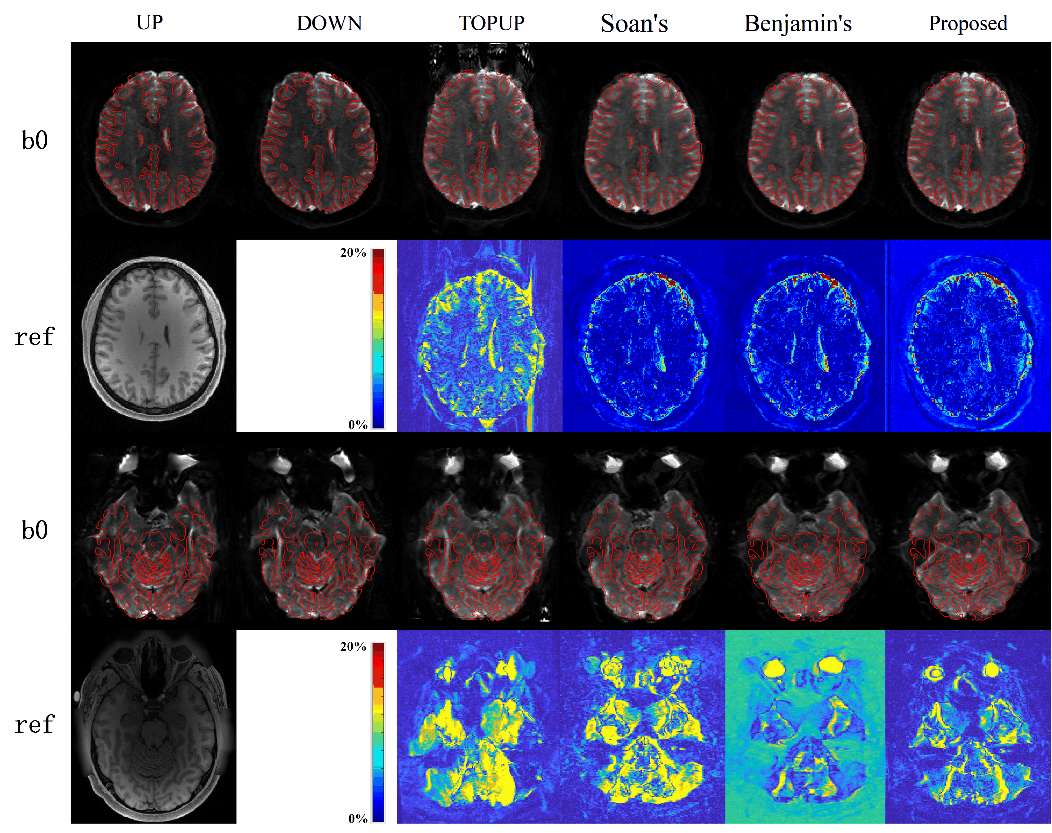

**FIGURE S3.** Comparison of the correction results for b5 images of DWI-3T test data. The edges extracted from the corresponding T2 images are overlaid onto the corrected images.

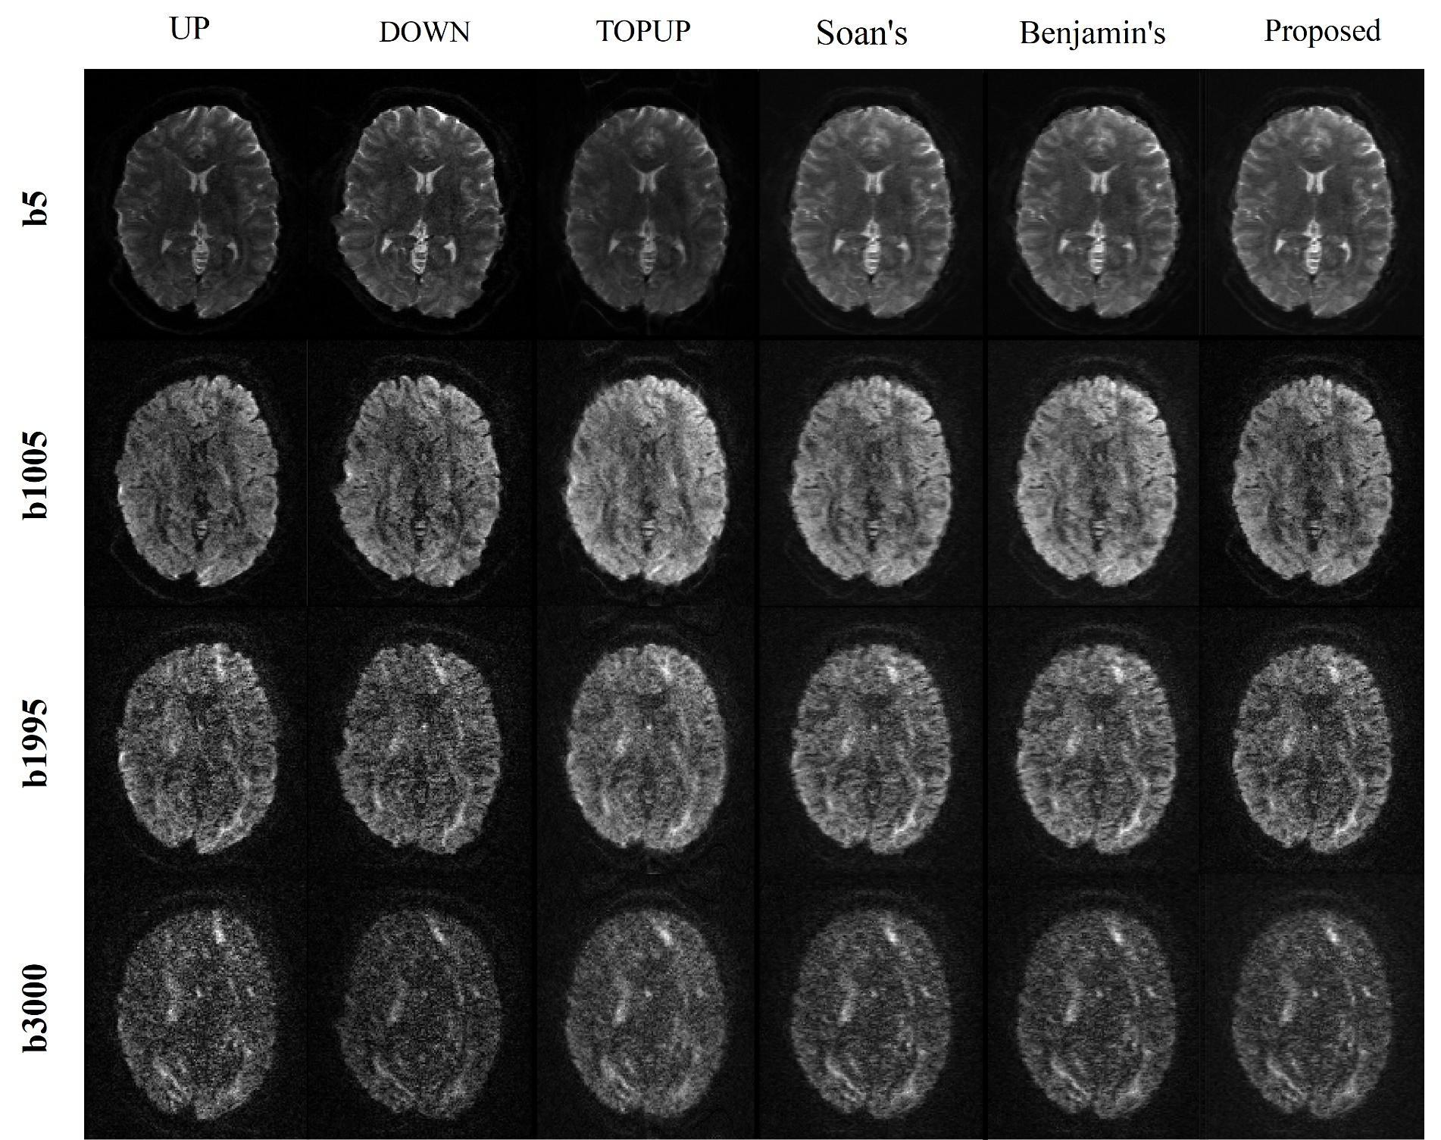

**FIGURE S4.** Comparison of the correction results for different diffusion-weighted images of DWI-3T test data

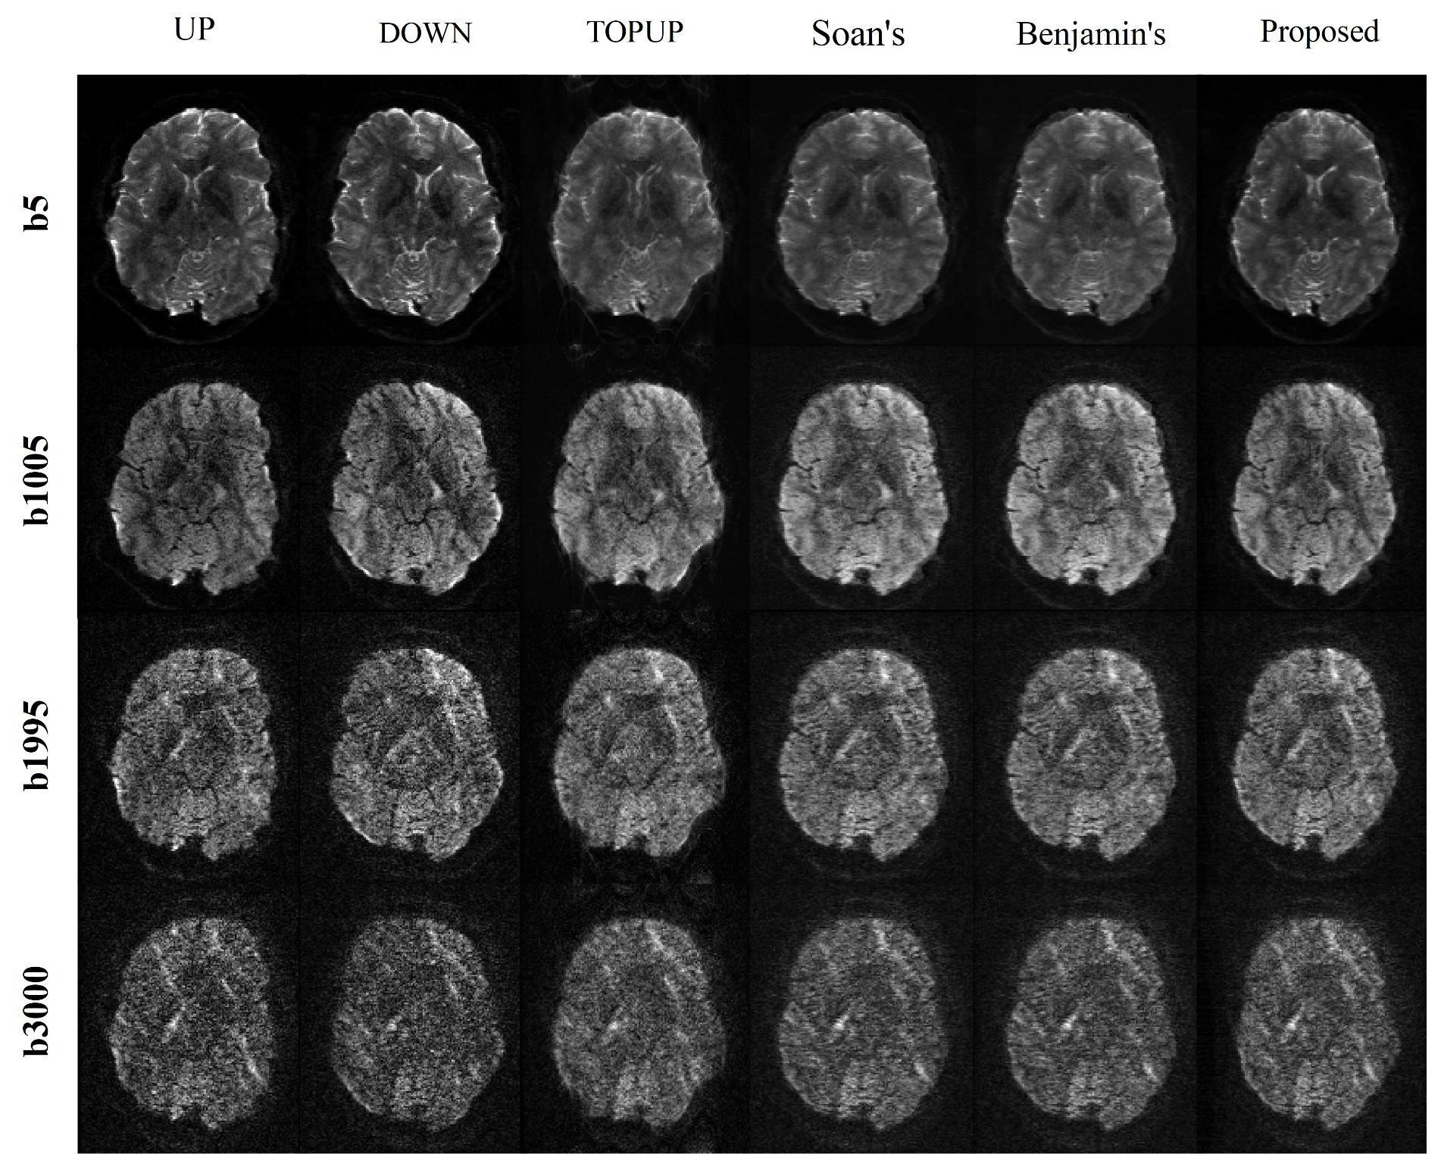

**FIGURE S5.** Comparison of the correction results for different diffusion-weighted images of DWI-3T test data.

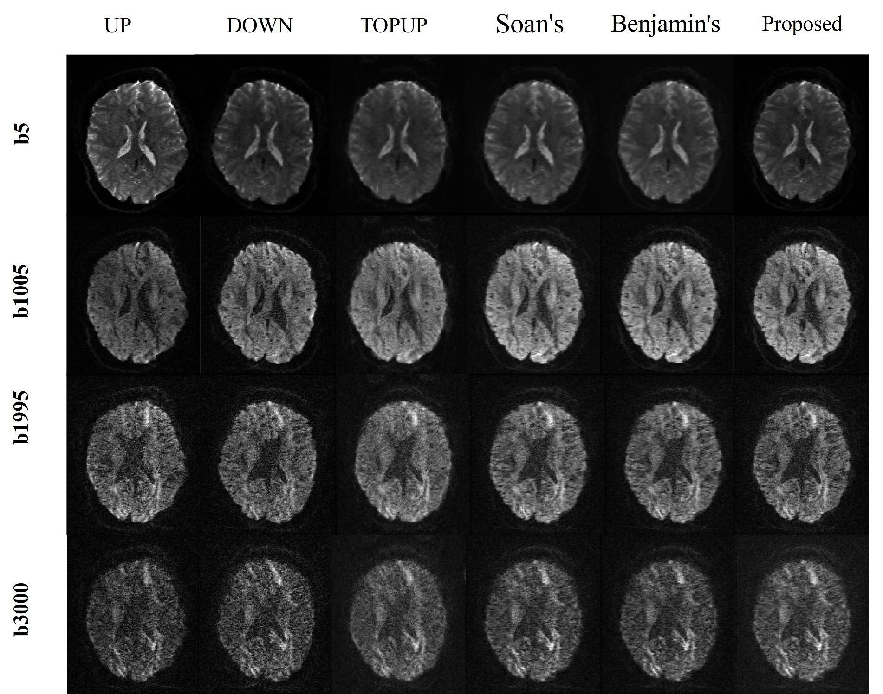

**FIGURE S6.** Comparison of the correction results for different diffusion-weighted images of DWI-3T test data

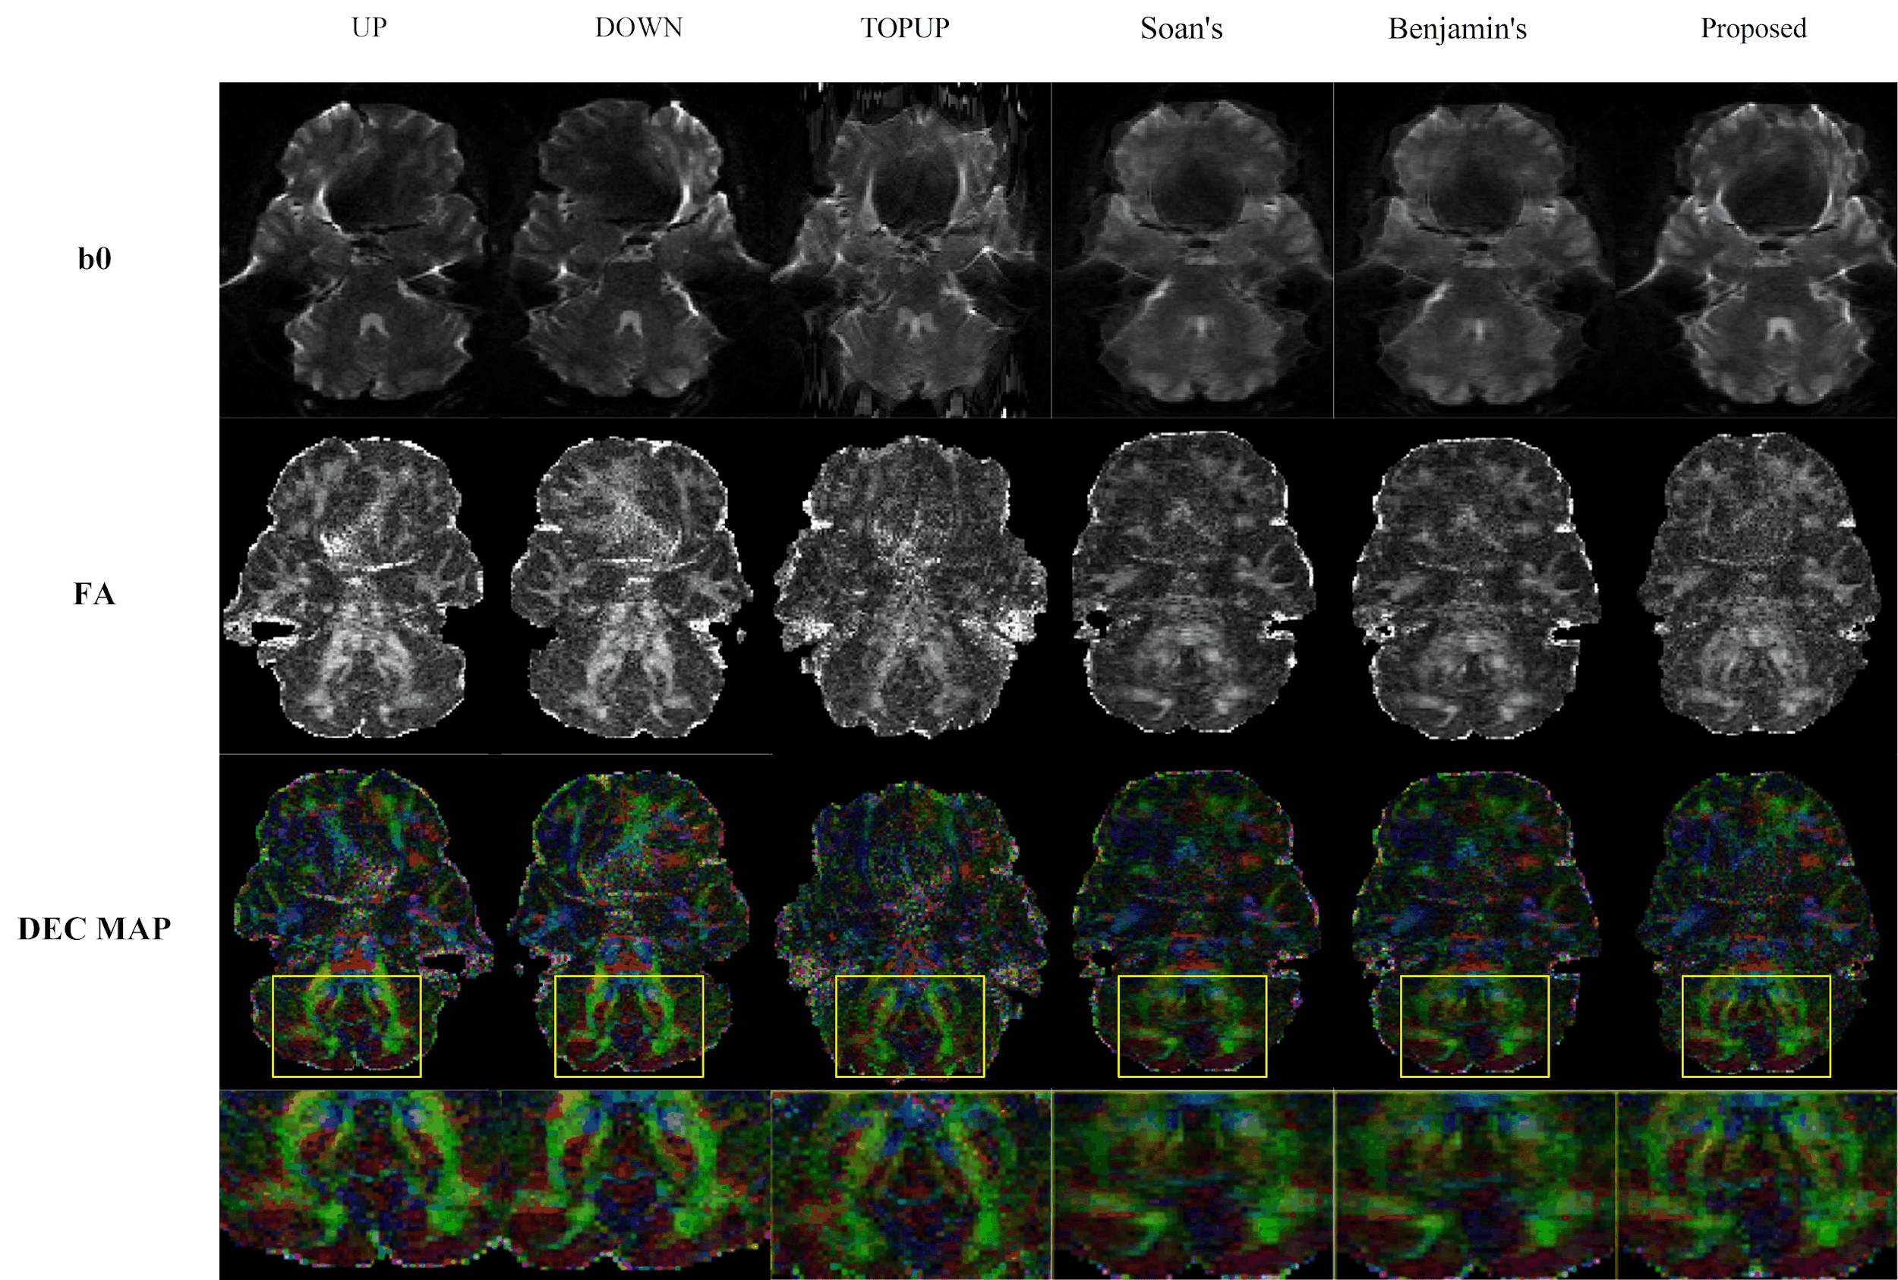

**FIGURE S7.** Comparison of the Fractional anisotropy (FA) maps based on different correction results for HCP DWI-3T.

## Additional preclinical data results

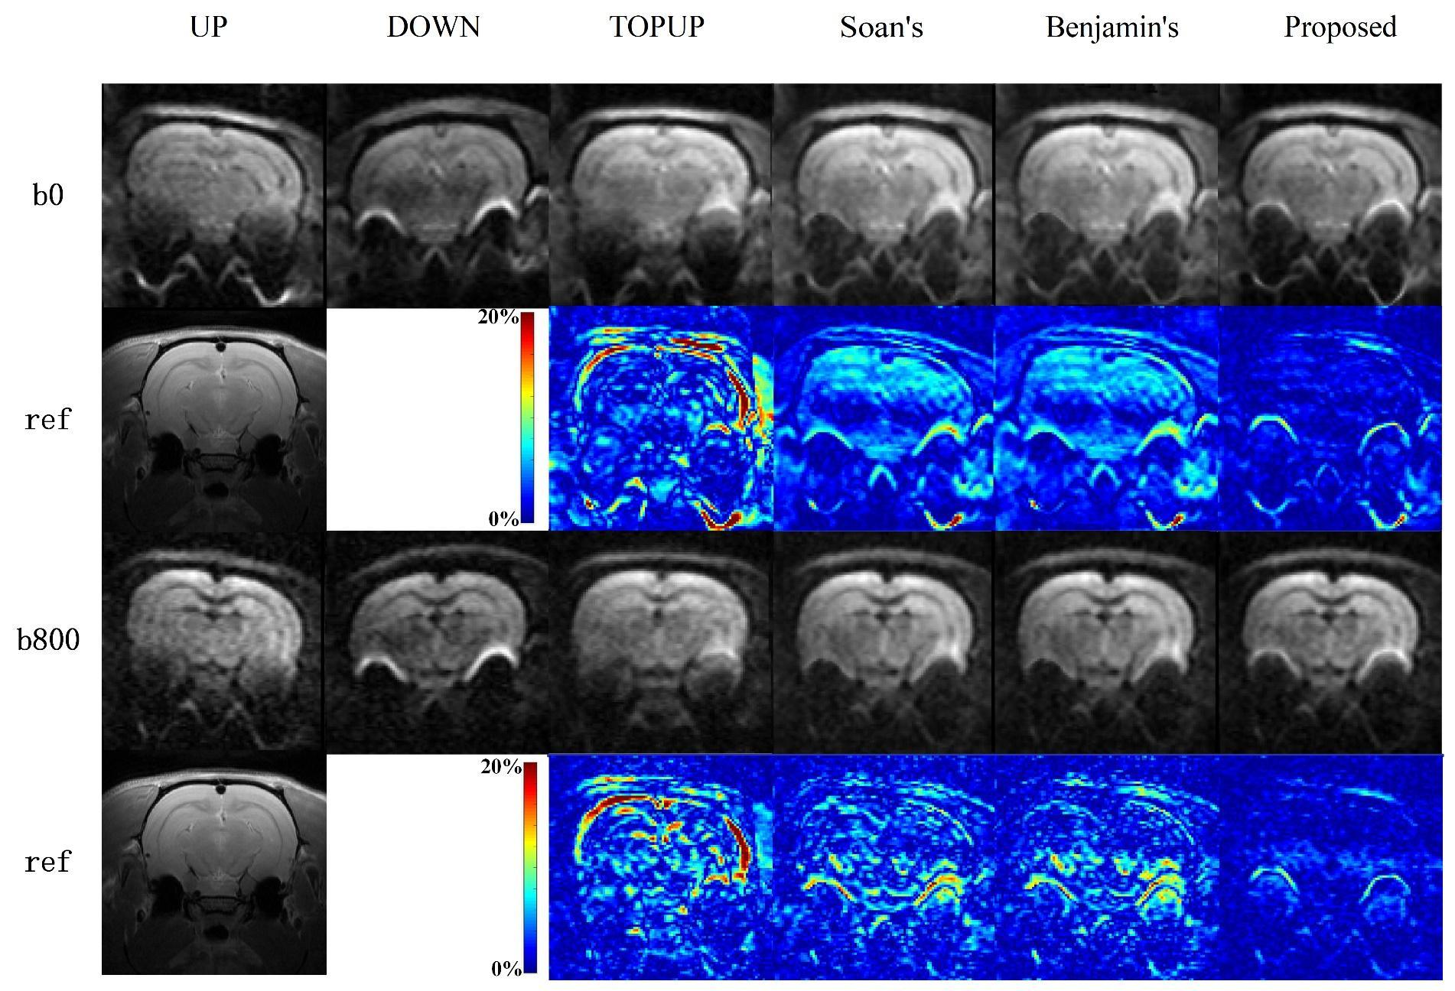

**FIGURE S8.** Comparison of different diffusion-weighted results for different correction methods of our laboratory DWI-7T dataset. The 1st and 3rd row show the correction results under different b values, and The 2nd and 4th row display the corresponding FSE image and the absolute error maps of cycle Up and Up.

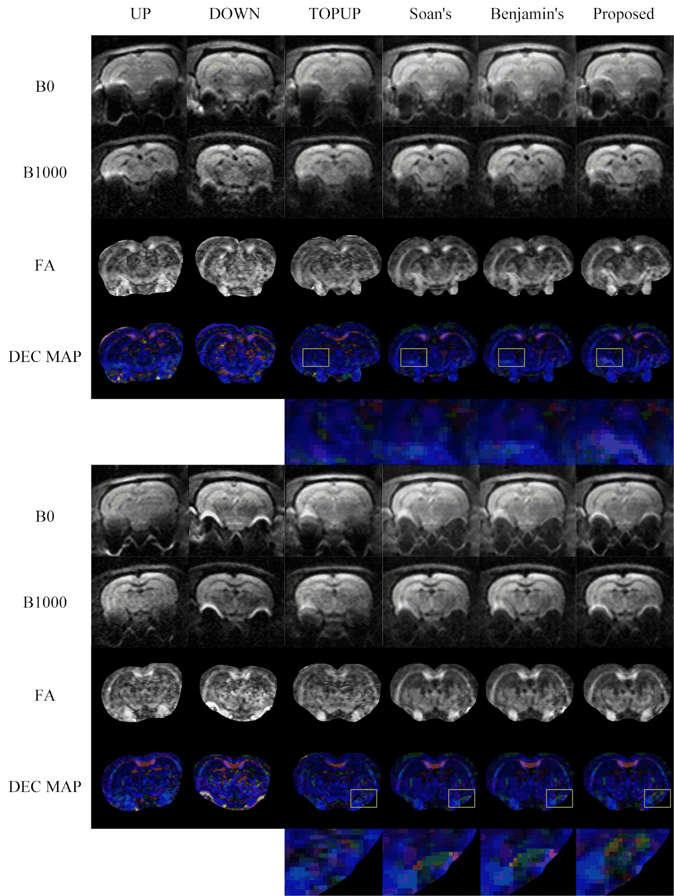

**FIGURE S9.** Comparison of Fractional anisotropy (FA) maps for two slices of different correction results for our laboratory DWI-7T data set.

## Other ablation experiment results

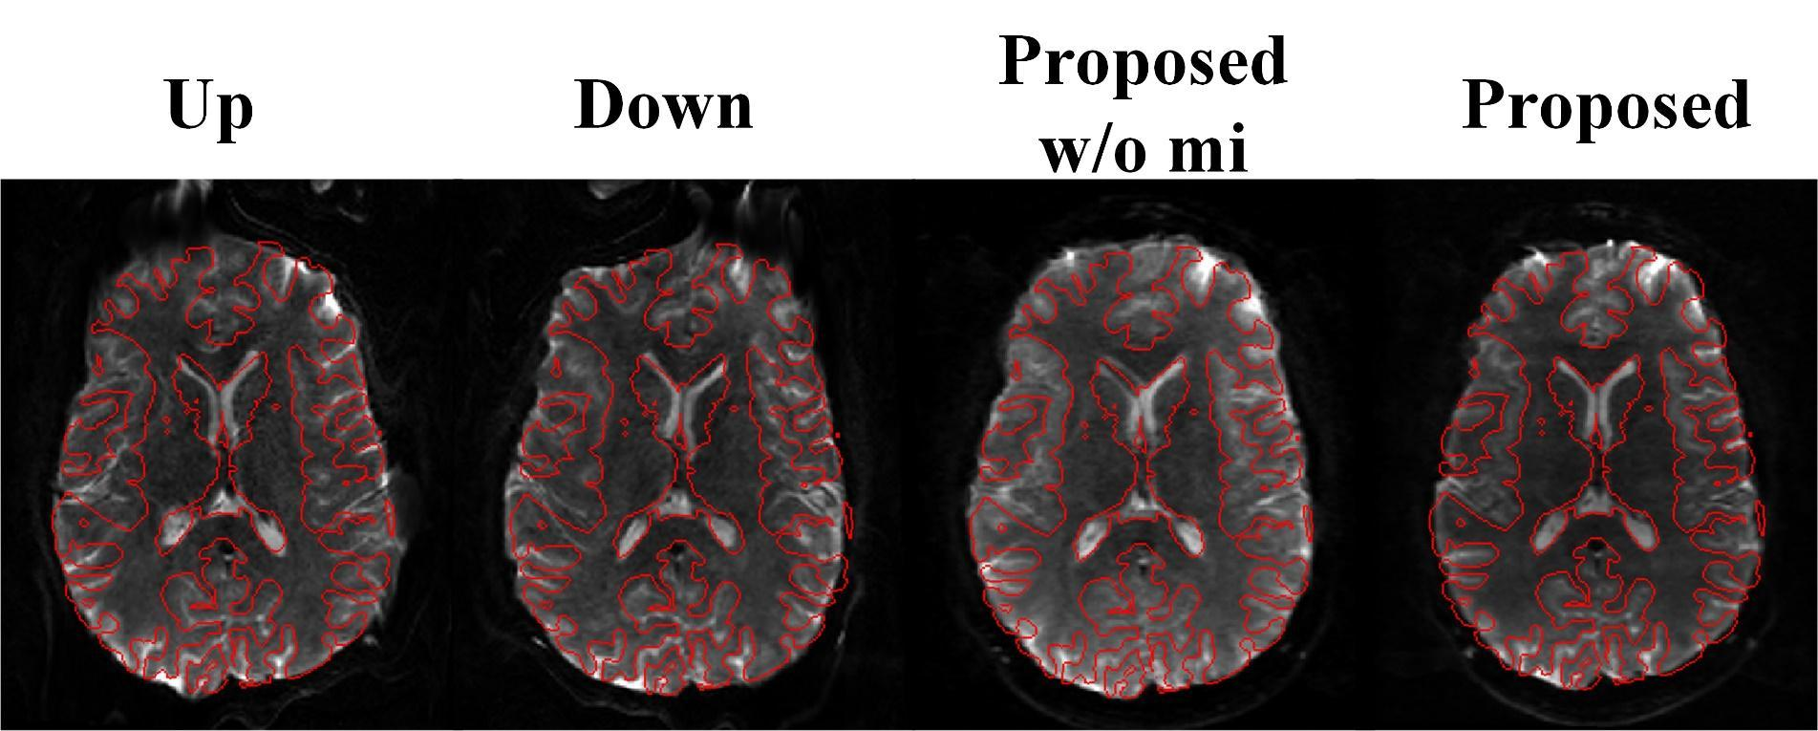

**FIGURE S10.** Comparison of performance of our proposed method with or without Multimodal similarity loss.

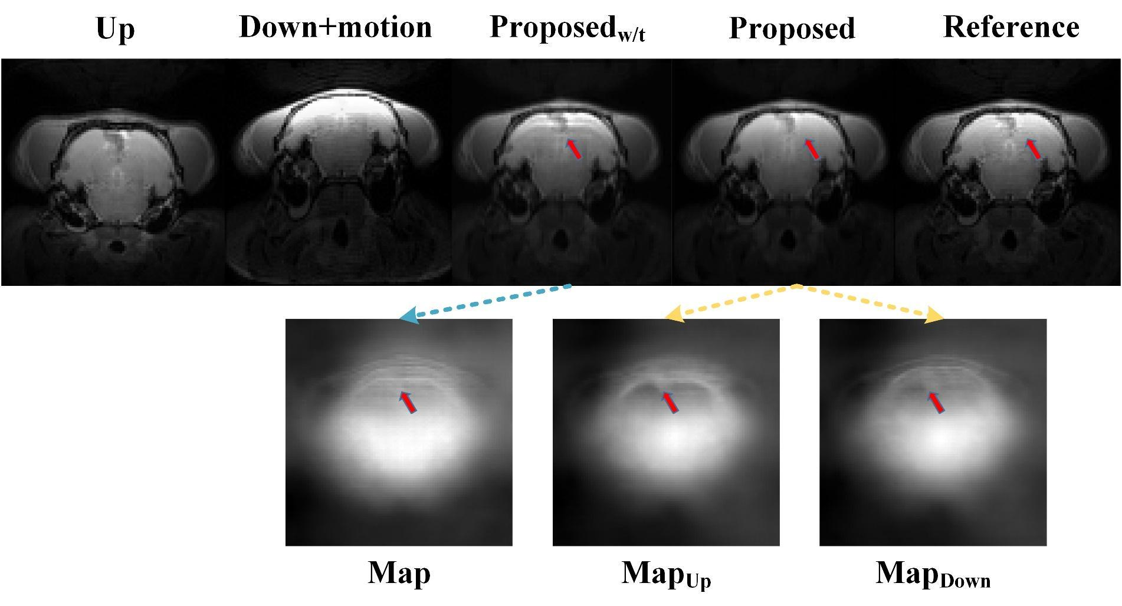

**FIGURE S11.** Comparison of performance of our proposed method with one displacement map (Proposedw/t) and two displacement map (Proposed).

## Hyperparameters for UCRSF-Net

The results in Table 2 show the influence of different parameter settings in the loss function on the final correction result. Table 3 displays the statistical comparisons of the PSNR and SSIM between the proposed method and other assessed methods on the test set of the simulated EPI-7T mice data set.

**Table S1**. Quantitative metrics of the chosen Hyper-parameters set of our Loss function.

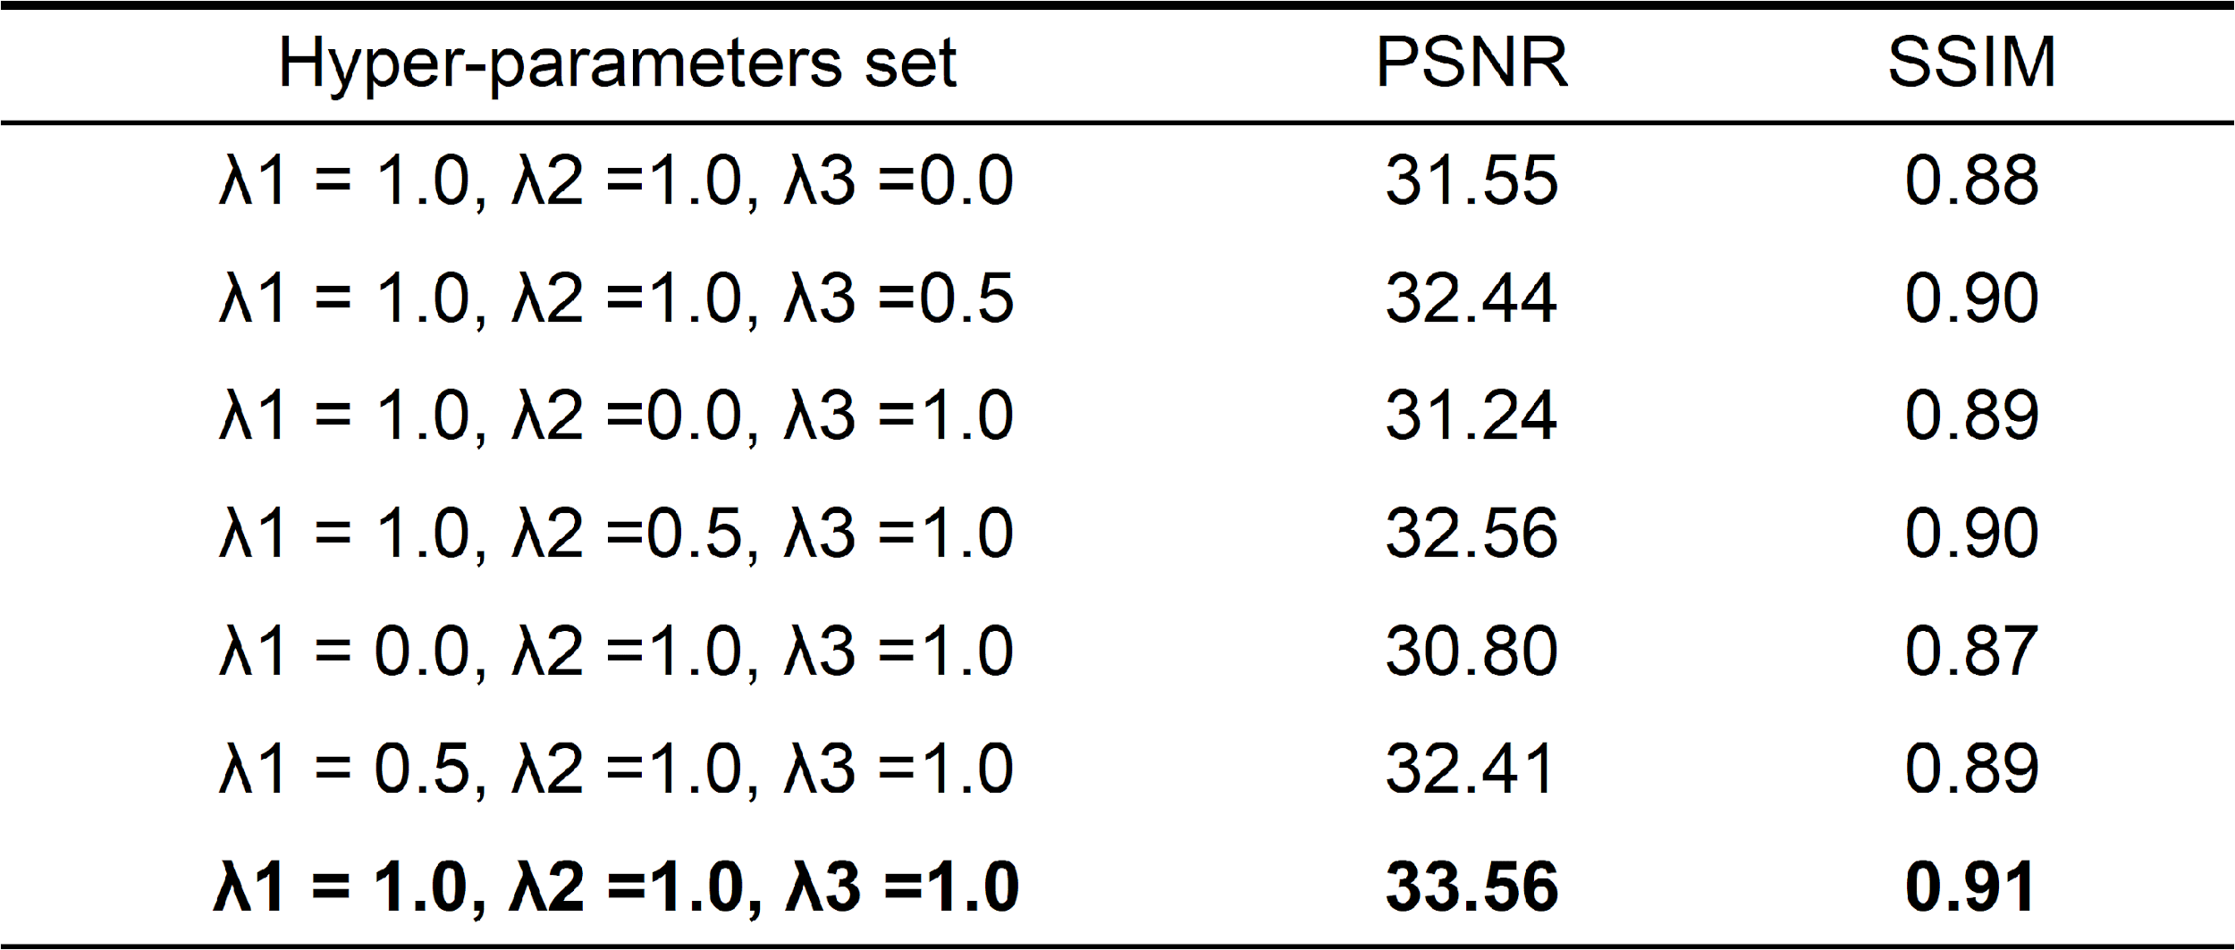

**Table S2**. Statistical comparisons of the PSNR and SSIM between the proposed method and other assessed methods on the test set.

|  |  |  |
| --- | --- | --- |
| Method | PSNR | SSIM |
| TOPUP | 27.21±1.81 | 0.81±0.04 |
| S-Net | 28.34±1.70 | 0.80±0.04 |
| Flow-Net | 26.10±2.00 | 0.79±0.05 |
| Proposed | 32.40±1.97 | 0.90±0.01 |